For this section, you will have the opportunity to list up to 15 experiences in the following categories:
- Artistic Endeavors
- Community Service/Volunteer - Medical/Clinical
- Community Service/Volunteer - Not Medical/Clinical
- Conferences Attended
- Extracurricular Activities
- Hobbies
- Honors/Awards/Recognitions
- Intercollegiate Athletics
- Leadership - Not Listed Elsewhere
- Military Service
- Other
- Paid Employment - Medical/Clinical
- Paid Employment - Not Medical/Clinical
- Physician Shadowing/Clinical Observation
- Presentations/Posters
- Publications
- Research/Lab
- Social Justice/Advocacy
- Teaching/Tutoring/Teaching Assistant
Each "Experience Description" is limited to 700 characters including spaces.
Note: a lot of identifying information (Experience name, location, dates, etc.) will be listed before you even start writing the Experience Description, so don't waste space by duplicating information!
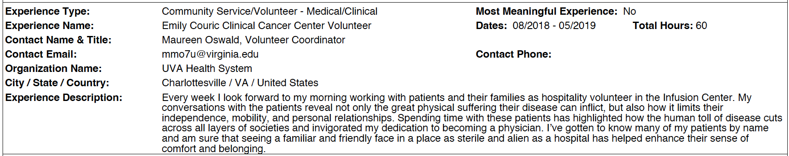
#1: Experience Type: Most Meaningful: Yes/No
Experience Name: Dates: Hours/Week:
Contact Name & Title:
Contact Email: Contact Phone:
Organization Name:
City/State/Country:
Experience Description (700 characters w/spaces):

#2: Experience Type: Most Meaningful: Yes/No
Experience Name: Dates: Hours/Week:
Contact Name & Title:
Contact Email: Contact Phone:
Organization Name:
City/State/Country:
Experience Description (700 characters w/spaces):

#3: Experience Type: Most Meaningful: Yes/No
Experience Name: Dates: Hours/Week:
Contact Name & Title:
Contact Email: Contact Phone:
Organization Name:
City/State/Country:
Experience Description (700 characters w/spaces):

#4: Experience Type: Most Meaningful: Yes/No
Experience Name: Dates: Hours/Week:
Contact Name & Title:
Contact Email: Contact Phone:
Organization Name:
City/State/Country:
Experience Description (700 characters w/spaces):

#5: Experience Type: Most Meaningful: Yes/No
Experience Name: Dates: Hours/Week:
Contact Name & Title:
Contact Email: Contact Phone:
Organization Name:
City/State/Country:
Experience Description (700 characters w/spaces):

#6: Experience Type: Most Meaningful: Yes/No
Experience Name: Dates: Hours/Week:
Contact Name & Title:
Contact Email: Contact Phone:
Organization Name:
City/State/Country:
Experience Description (700 characters w/spaces):

#7: Experience Type: Most Meaningful: Yes/No
Experience Name: Dates: Hours/Week:
Contact Name & Title:
Contact Email: Contact Phone:
Organization Name:
City/State/Country:
Experience Description (700 characters w/spaces):

#8: Experience Type: Most Meaningful: Yes/No
Experience Name: Dates: Hours/Week:
Contact Name & Title:
Contact Email: Contact Phone:
Organization Name:
City/State/Country:
Experience Description (700 characters w/spaces):

#9: Experience Type: Most Meaningful: Yes/No
Experience Name: Dates: Hours/Week:
Contact Name & Title:
Contact Email: Contact Phone:
Organization Name:
City/State/Country:
Experience Description (700 characters w/spaces):

#10: Experience Type: Most Meaningful: Yes/No
Experience Name: Dates: Hours/Week:
Contact Name & Title:
Contact Email: Contact Phone:
Organization Name:
City/State/Country:
Experience Description (700 characters w/spaces):

#11: Experience Type: Most Meaningful: Yes/No
Experience Name: Dates: Hours/Week:
Contact Name & Title:
Contact Email: Contact Phone:
Organization Name:
City/State/Country:
Experience Description (700 characters w/spaces):

#12: Experience Type: Most Meaningful: Yes/No
Experience Name: Dates: Total Hours:
Contact Name & Title:
Contact Email: Contact Phone:
Organization Name:
City/State/Country:
Experience Description (700 characters w/spaces):

For 3 of your 15 Experiences, you’ll annotate them as "Most Meaningful Experience". Keep in mind - you still have a basic "Experience Description" with 700 characters (including spaces!), but you also have an additional 1325 characters (including spaces) to write why it was so meaningful to you.
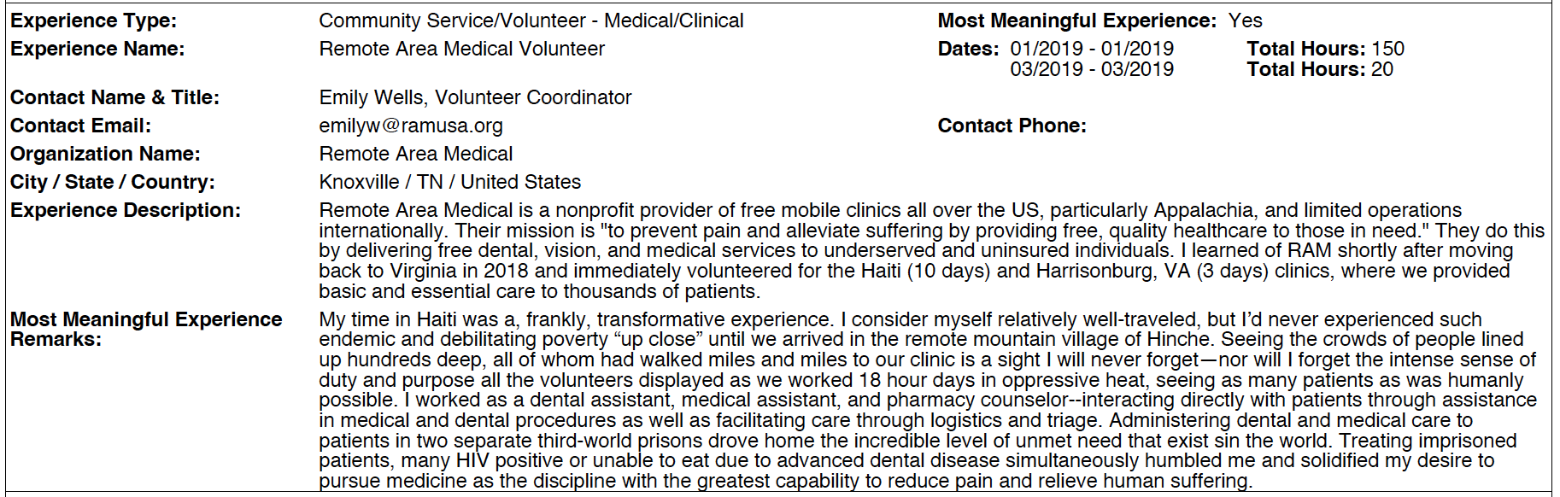

#13: Experience Type: Most Meaningful: Yes/No
Experience Name: Dates: Hours/Week:
Contact Name & Title:
Contact Email: Contact Phone:
Organization Name:
City/State/Country:
Experience Description (700 characters w/spaces):
Most Meaningful Experience Remarks (additional 1325 characters w/spaces):

#14: Experience Type: Most Meaningful: Yes/No
Experience Name: Dates: Hours/Week:
Contact Name & Title:
Contact Email: Contact Phone:
Organization Name:
City/State/Country:
Experience Description (700 characters w/spaces):
Most Meaningful Experience Remarks (additional 1325 characters w/spaces):

#15: Experience Type: Most Meaningful: Yes/No
Experience Name: Dates: Total Hours:
Contact Name & Title:
Contact Email: Contact Phone:
Organization Name:
City/State/Country:
Experience Description (700 characters w/spaces):

Most Meaningful Experience Remarks (additional 1325 characters w/spaces):

